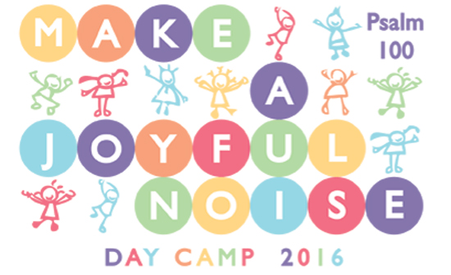

Day Camp
San Marcos Lutheran Church
3419 Grand Ave San Marcos CA 92078
Monday July 11- Friday July 15
9 am – 3 pm
$125 per camper
(full and partial scholarships ALWAYS available)
For ages Kindergarten through 6th Grade

Go to www.SanMarcosLutheran.org for registration and medical release forms.

Question? Contact Pastor Karla Halvorson
PastorKarlaSMLC@Sbcglobal.net
760-727-1509
Barbara Velivis barbaravelivis@gmail.com

